

**Machine Learning for Product Managers**

Uber Eats

|  |  |
| --- | --- |
| **1.** **Intro to ML** **2.** **When to ML**  **3.** **How to ML** | **4.** **Get Your Data**  **5.** **Prepare Your Data**  **6.** **Deploy Your Model** |

**Section 1: Intro to ML**

**Exercise #1: Choose Your Product (15 minutes)**

|  |  |  |
| --- | --- | --- |
| Product Name | Uber Eats | |
| What does it do? | On-demand food delivery service | |
| Where is it available? | In 45 countries & 6000 cities Desktop via browser (ubereats.com)  Mobile & Tablet - Android  Mobile & Tablet - iOS |  |
| Existing ML use cases | * What restaurants to onboard to Uber Eats * What foods/restaurants to recommend to users * When to dispatch a driver for food pick-up * What is the estimated delivery time | |
| Your Role | ML Product Manager - Fulfillment | |

**Exercise #2a: What type of ML is this? (5 minutes)***Identify the ML problem type for each example provided*

|  |  |  |  |  |  |  |
| --- | --- | --- | --- | --- | --- | --- |
| **Example** | **Ranking** | **Recommendation** | **Classification** | **Regression** | **Clustering** | **Anomaly Detection** |
| **Google Home**: “Find some good restaurants near me” | **X** |  |  |  |  |  |
| **Experian:** Gives you a credit score of 780 |  |  |  | **X** |  |  |
| **Citibank:** Sends you an email about a “suspicious” transaction |  |  |  |  |  | **X** |
| **Netflix**: Says “Because you watched XXX you may like YYY also” |  | **X** |  |  |  |  |
| **Google Photos:** Auto-tags a photo as a “beach photo” |  |  | **X** |  |  |  |
| **Amazon**: Shows “products related” to an item you are viewing |  |  |  |  | **X** |  |

**Exercise #2b: What type of ML is this? (15 minutes)***Find examples of each ML problem type in the products you use*

|  |  |
| --- | --- |
| **Type** | **Example** |
| Ranking |  |
| Recommendation |  |
| Classification |  |
| Regression |  |
| Clustering |  |
| Anomaly Detection |  |

**Exercise #3: Apply your ML lingo (10 minutes)**

*Your ML model predicts whether a Facebook account is fake or real. Based on the table below, classify aspects of the data as “feature” or “label”*

|  |  |  |  |  |
| --- | --- | --- | --- | --- |
| Facebook Message | # of Likes | Account Gender | # of Friends | Fake or Real |
| One day sale on sunglasses [🕶️](https://emojipedia.org/sunglasses/) | 122 | Male | 2 | Fake |
| Beautiful day for swimming [🏊](https://emojipedia.org/emoji/%F0%9F%8F%8A/) | 64 | Female | 48 | Real |

|  |  |
| --- | --- |
| **Classify this** | **Feature or Label?** |
| Facebook Message | Feature |
| # of Likes | Feature |
| Fake | Label |
| # of Friends | Feature |

*Classify each decision made below as a “feature engineering” or “feature selection" activity*

|  |  |
| --- | --- |
| **Classify this** | **Feature Engineering or Feature Selection?** |
| Account gender = Male, Female, Not Known, Not Applicable | Feature Engineering |
| Account gender is not useful for predicting if an account is fake | Feature Selection |
| Convert message timestamp to UTC format | Feature Engineering |

**Section 2: When to ML**

**Exercise #4: Need Explainability? (5 minutes)**

*Which of the potential ML use cases below need to be explainable?*

|  |  |  |
| --- | --- | --- |
| Use Case | Need Explainability?  (Y/N) | Why?   (Legal/Financial/Medical/Ethical Risks) |
| Amazon recommends a book based on a recent purchase | N | Legal - None Financial - Low Medical - None Ethical - None |
| Tesla Auto-pilot decides not to swerve to avoid hitting a small animal for driver safety reasons | Y | Legal - High  Financial- High  Medical- High  Ethical- High |
| Bank rejects an application for a home mortgage | Y | Legal - Medium Financial - High  Medical - None Ethical - Medium |
| Facebook suggests that your friends tag you in a photo | N | Legal - Low Financial - Low Medical - Low  Ethical - Low |

**Exercise #5: To ML or not to ML? (15 minutes)**

*Which of these use cases are good candidates for ML? (assuming you have the right skill & resources available)*

|  |  |  |  |  |  |  |  |  |
| --- | --- | --- | --- | --- | --- | --- | --- | --- |
|  | **Use Case** | **Complex Problem?**  **(Y/N)** | **Changes Over Time?   (Y/N)** | **Need to Scale?  (Y/N)** | **Need 100% Accuracy**  **(Y/N)** | **Needs to be Explainable?**  **(Y/N)** | **Is this Ethical?  (Y/N)** | **Solve Using ML?  (Y/N)** |
| 1) | Which distributors have the greatest sales potential | Y | Y | Y | N | Y | Y | Y |
| 2) | Which products should be sold exclusively to Hispanics in the US | Y | Y | Y | N | Y | N | N |
| 3) | Which employees are likely to leave in next 6 months | Y | Y | Y | N | N | Y | Y |
| 4) | Which resumes should be prioritized for interviewing? | Y | Y | Y | N | N | N | N |
| 5) | Which products need to be protected by copyright laws | Y | Y | Y | Y | N | N | N |

**Section 3: How to ML**

**Exercise #6: Test Your Hypothesis (30 minutes)**

1. *Identify a potential ML use case for your chosen product.*

|  |  |  |  |  |  |  |  |
| --- | --- | --- | --- | --- | --- | --- | --- |
| **Use Case** | **Complex Problem?**  **(Y/N)** | **Changes Over Time?   (Y/N)** | **Need to Scale?  (Y/N)** | **Need 100% Accuracy**  **(Y/N)** | **Needs to be Explainable?**  **(Y/N)** | **Is this Ethical?  (Y/N)** | **Solve Using ML?  (Y/N)** |
| Predict time needed to prepare food | Y | N | Y | N | N | Y | Y |

1. *State your hypothesis using the following format:*

|  |  |
| --- | --- |
| ***Format*** | ***Uber Eats Example*** |
| *We believe our [target market]*  *Have a problem of [assumption]*  *If we [proposed solution]*  *We can [expected impact]* | *We believe our [delivery partners]*  *Have a problem of [struggling to predict when food will be ready for pick-up]*  *If we [build an ML model that provides a “food preparation time” prediction]*  *We can [improve on-time pickups by 20% within 4 months]* |

1. *Identify risky assumptions:*

|  |  |
| --- | --- |
| Assumption #1 | Delivery partners struggle to predict when food will be ready for pickup |
| Why? | Prep times vary for different food types → complex vs simple recipes |
| Why? | Prep times vary based on time of day → peak vs off-peak times |
| Why? | Prep times vary based on # of staff available → under-staffed vs extra help |
| Why? | Prep times vary between restaurants → fast food vs fine dining |
| Why? | Restaurants unable to provide a time estimate for each order |
| Assumption #2 | Poor time predictions create problems |
| Why? | Delivery person waits for food → parking space occupied & fewer deliveries made |
| Why? | Food waits for delivery person → cold food |
| Why? | Customer cannot get a reliable delivery time estimate → unhappy customer |

1. *Validate risky assumptions:*

|  |  |
| --- | --- |
| #1: Delivery partners struggle to predict when food will be ready for pickup | How to test |
| Prep times vary for different food types → complex vs simple recipes | - Interview delivery partners  - Analyze data for on-time pickups  - Interview restaurants  - Trial solution where restaurant supplies time estimate |
| Prep times vary based on time of day → peak vs off-peak times |
| Prep times vary based on # of staff available → under-staffed vs extra help |
| Prep times vary by # of items in order →made in parallel or sequentially |
| Prep times vary between restaurants → fast food vs fine dining vs speciality |
| Restaurants unable to provide a time estimate for each order |
| #2: Not knowing when food will be ready creates problems | How to test |
| Delivery person waits for food → parking space occupied | - Interview restaurants  - Analyze data for on-time deliveries |
| Food waits for delivery person → cold food |
| Customer cannot get a reliable delivery time estimate → unhappy customer |

**Exercise #7: Frame Your ML Problem (20 minutes)**

*a) What do you want your machine learning model to do? (****Tip****: A qualitative statement focused on a real goal.)  
  
The ML model should..*

|  |
| --- |
| *Estimate the time needed to prepare food for an order, factoring in things like type of food, type of restaurant, number of items in the order and how busy the restaurant is at that point in time.* |

*b) Write down the success and failure metrics for the ML system.*

*Our success metrics are..*

|  |
| --- |
| *20% improvement in on-time pickups   A pick-up is considered on-time if actual pick-up is within +/- 5 minutes of when restaurant reports food order ready* |

*Our model is deemed a failure if..*

|  |
| --- |
| *It delivers anything below a 5% improvement in on-time pickups* |

*c) Write the output that you want your ML model to produce.*

*The output from our ML model will be..*

|  |
| --- |
| *A prediction of time needed to prepare food where*  *Time to prepare*  *Starts when restaurant accepts the order, and*  *Ends when the restaurant reports food order is ready* |

*d) Write when the output from the ML model needs to be available & how it will be used.*

*The output will need to be made available when..*

|  |
| --- |
| *A customer places an order with a restaurant* |

*The output will be used for..*

|  |
| --- |
| *1) Deciding which delivery partner to dispatch*  *2) Deciding when to dispatch them for pick-up*  *3) Calculating Estimated Delivery Time for presenting to customer* |

**Exercise #8: Formulating Your ML Problem (20 minutes)**

1. *Use the flowcharts below to identify your ML Problem type*

For classification problems

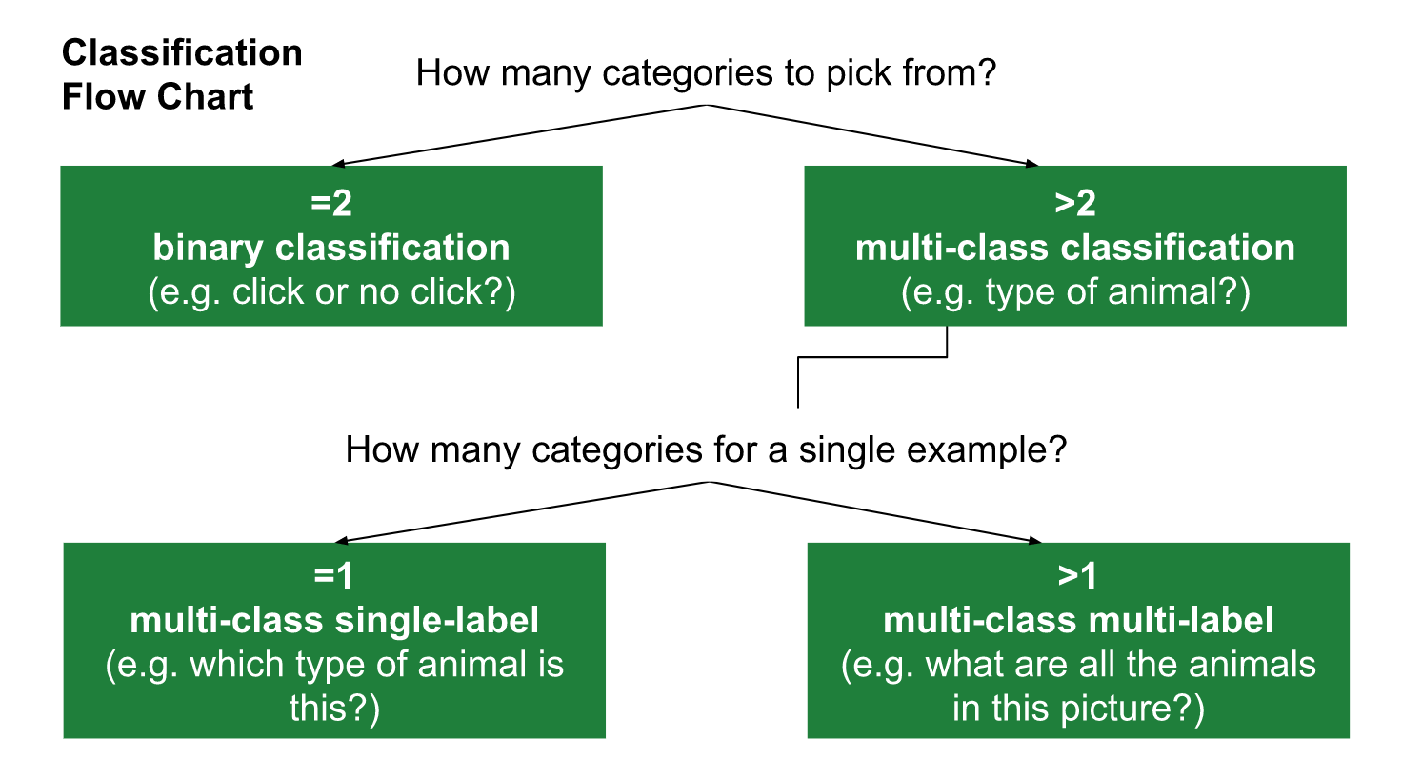

For regression problems

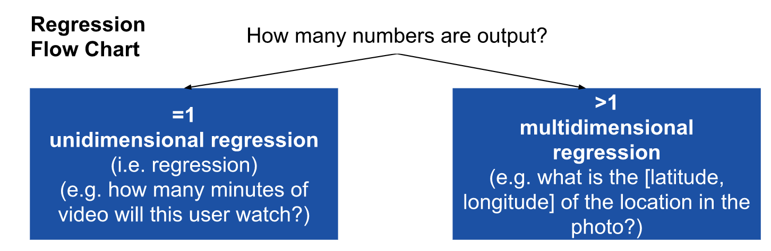

|  |  |
| --- | --- |
| **Our problem is best framed as...** |  |
| Binary classification |  |
| Unidimensional regression | X |
| Multi-class single-label classification |  |
| Multi-class multi-label classification |  |
| Multidimensional regression |  |
| Clustering (unsupervised) |  |

1. *Define your problem statement*

|  |
| --- |
| Our problem is best framed as uni-dimensional regression, which predicts a food  preparation time in minutes & seconds, when a customer places an order |

**Section 4: Get Your Data**

***Exercise #9: User-Generated Data Labelling (15 mins)***

*In the products you use every day, try to find 2 examples of user-generated data labelling.*

**Did you know**? CAPTCHA stands for Completely Automated Public Turing test to tell Computers and Humans Apart.

|  |  |  |  |
| --- | --- | --- | --- |
| Product name | What the user does | Image | How the label may be used |
| Google Image reCAPTCHA v2 | A user has to identify images that contain certain objects, such street signs.   - Pre-labelled images are used to ensure the user is not a bot.   - Un-labelled images are labelled by users to help Google build ML datasets |  | Google Maps  Waymo (self driving cars) |
| Grammerly | A user receives feedback to correct a possible grammatical error but decide to ignore it by selecting “ignore”  - This “ignore” label is retained |  | Improving the ML model(s) with suggestions that have high ignore rates |

***Exercise #10: Design your data for the model (15 mins)***

*Write the data you want the ML model to use to make predictions i.e. your initial features*

*For Uber Eats*

|  |  |  |  |
| --- | --- | --- | --- |
| Ave. Prep Time | Order Size | Time of Day | Preparation Time |
| mm:ss | # of items | hh:mm:ss | mm:ss |

*For Your Product*

|  |  |  |  |
| --- | --- | --- | --- |
| Feature 1 | Feature 2 | Feature 3 | Target |
|  |  |  |  |

Tips:

* For the initial model, pick easy to obtain features that you feel will deliver a reasonable initial prediction.
* Only include features that will be available at the moment the prediction is made.
* Consider where your data will come from.

**Section 5: Prepare Your Data**

***Exercise #11: Engineer New Feature Candidates (20 mins)***

*Brainstorm 2 new feature candidates for your ML model*

*Tip: Look for things that might impact your prediction, outside your initial set of features*

*For Uber Eats*

|  |  |  |  |
| --- | --- | --- | --- |
| Feature | Description | Format | *Source* |
| Food Type | To factor in cuisine type | {Soup, smoothie, sandwich, salad...} | Menu data |
| Weekend | Weekends are busier | Yes/No | Order Date |

*For Your Product*

|  |  |  |  |
| --- | --- | --- | --- |
| Feature | Description | Format | *Source* |
| Feature #1 |  |  |  |
| Feature #2 |  |  |  |

**Section 7: Deploy Your Model**

***Exercise #12 a:******Calculate Evaluation Metrics*** *(****10 mins)***

*Using the confusion matrix below, answer the following questions*

|  |  |  |
| --- | --- | --- |
|  | Predicted No | *Predicted Yes* |
| *Actual No* | 94 | 23 |
| *Actual Yes* | 24 | 100 |

*a. Number of true positives?*

*100*

*b. Number of false negatives?*

*24*

*c. Number of true negatives?*

*94*

*d. Number of false positives?*

*23*

***Exercise #12 b: Calculate Evaluation Metrics***

*Suppose we design a model to identify iphones from a video that also contain android phones. The program identifies 5 iphones in a scene containing 7 iphones and some android phones. If 3 of the identifications are correct but 2 are actually android phones…*

a. What is the precision of the model?

TP = 3

FP = 2  
  
Precision = TP / (TP + FP) = 3 / (3 + 2) = 0.6

b. What is the recall of the model?

FN = 4

Recall = TP / (TP + FN) = 3 / (3 + 4) = 0.429

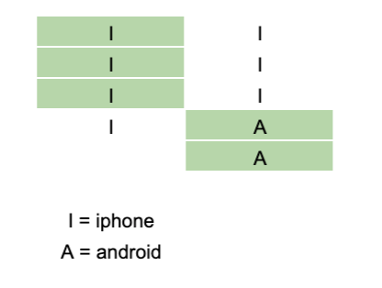

***Exercise #13:******Precision, Recall or F1 Score?*** *(****10 mins)***

*In the scenarios below, would you optimize for precision, recall, or F1 Score?*

|  |  |  |  |
| --- | --- | --- | --- |
| An ML model to... | Precision | Recall | F1 Score |
| Predict whether a certain day is a good day to launch satellites based on the weather. | X |  |  |
| Detect fraudulent insurance claims. |  | X |  |
| Detect spam emails. | X |  |  |
| Detect new products that need copyright protection. |  | X |  |
| Provide a search engine. |  |  | X |